**McDonald's Automation Push Is Great News for Investors**

Automation is allowing the company to experiment and acting as a buffer against rising labor costs.

Keith Noonan

Mar 4, 2017 at 9:00AM

As one of the world's largest employers, **McDonald's**([NYSE:MCD](https://www.fool.com/quote/nyse/mcdonalds/mcd)) often finds itself at the center of debates about wages and the potential effects of automation. Rising labor costs pose a threat to the company and its franchisees, and the scale is starting to tip in favor of developing technology being cost-effective enough to replace human jobs.

The restaurant chain's new automation push is still in its early stages and can be counted on as a source of controversy in the years to come, but the effects of the trend stand to create long-term tailwinds for McDonald's and its investors.

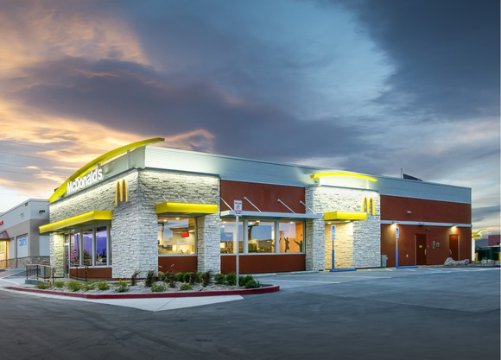

IMAGE SOURCE: MCDONALD'S.

**Kiosks and mobile ordering are changing fast food**

McDonald's is in the process of bringing self-order kiosks to all of its locations, and this initiative, along with the rollout of mobile-based ordering and payment, presents a way to improve functions and efficiency throughout the chain. Perceived quality of service has been an issue for the company, and reducing employee-customer interaction has the potential to relieve friction and free up employees to perform other tasks. Studies and customer feedback have also indicated that a substantial portion of the millennial generation prefers to bypass human interaction when placing orders, so the new initiatives could help to ingratiate Mickey D's with one of its most crucial age demographics.

The surge in kiosk and mobile adoption is occurring industry wide and points to technology that's becoming increasingly attractive. **Wendy's**([NASDAQ:WEN](https://www.fool.com/quote/nasdaq/wendys/wen)) recently announced that it will add self-ordering stations at 1,000 of its restaurants by the end of 2017, and **Panera Bread** plans to have kiosks at all of its locations within the next several years. Other competitors, including Burger King, CKE Restaurants, and Tim Hortons are also transitioning to automated ordering.

McDonald's hasn't given much color on the expenses of adding self-order stations, but comments from Wendy's management could provide some insight. Wendy's Chief Information Officer David Trimm has indicated that franchisees will pay roughly $15,000 for three ordering kiosks, and he anticipates that it will take less than two years for the benefits created by self-ordering kiosks to offset the investment. The timeline to break even is probably similar for McDonald's franchisees, and the benefits of kiosks will likely become more pronounced with time.

**Automating for a more flexible McDonald's**

Shifting to this new technology requires that stores continue to employ cashiers to assist with the new process and cater to customers who prefer traditional service. But the need for these roles should fall as kiosks become the norm, leaving employees free to take on other roles. Kiosks have already freed up some McDonald's staff to provide table service, and the company is testing curbside delivery in conjunction with mobile ordering and payment.

Automated ordering also means that more workers should be available for the kitchen, helping to address franchisee concerns about increasingly complicated menus and challenges related to customization. CEO Steve Easterbrook believes that the perception of time constraints can make ordering at McDonald's stressful and that this issue can be alleviated through the company's new investments. He has also indicated that the additional time to peruse the menu encourages customization and premium sales, generating higher average spending per consumer.

**An answer to the rising cost of labor**

Payscale lists the median wage for an American fast food worker at $8.24 per hour, a far cry from the $15 per hour benchmark that many groups are calling for. With labor often making up 20% or more of costs for this industry, sizable increases to payroll can reasonably be expected to be passed onto consumers. That presents a major problem for value-focused restaurants like McDonald's.

In the U.S., the fast food chain is struggling with declining traffic but has managed to offset this trend by increasing the average spending per check. The extent to which the company can continue to raise prices is limited, however. McDonald's thrives by offering low-cost food options -- a model that makes it very sensitive to increasing expenses. While food and materials may fall mostly outside the company's control, it will enjoy increasing flexibility with labor thanks to the automation trend.

Easterbrook has been careful when commenting on the likelihood of new technologies that will eliminate jobs, but competitors including Wendy's and CKE Restaurants have directly linked their respective automation efforts to rising labor costs, touting the benefits of smaller in-store headcounts. Talking about replacing workers with technology might not be politically expedient for McDonald's at the moment, but a pared-down workforce is almost certainly a desirable outcome for the company -- and one it is certain to explore going forward.

[*Keith Noonan*](http://my.fool.com/profile/keithnoonan/info.aspx)*has no position in any stocks mentioned. The Motley Fool owns shares of and recommends Panera Bread. The Motley Fool has a*[*disclosure policy*](http://www.fool.com/Legal/fool-disclosure-policy.aspx)*.*

<https://www.fool.com/investing/2017/03/04/mcdonalds-automation-push-is-great-news-for-invest.aspx>