**Fast-Food Stocks: Which Chain Has the Quickest Drive-Through?**

You may be surprised to learn who’s at the top and bottom of the list.

John Maxfield

Feb 12, 2017 at 8:14AM

Have you ever sat in the drive-through of a fast-food restaurant and thought: "Wasn't this supposed to be fast?" I suspect you have.

I'm not proud to admit it, but I love fast food. And on the occasions when I get it, though I've mostly weaned myself over the past few years, I almost always use the drive-through.

This led me to wonder if there are studies that compare the wait times of the different drive-through chains, or at least the major ones such as **McDonald's** ([NYSE:MCD](https://www.fool.com/quote/nyse/mcdonalds/mcd)), **Wendy's**([NASDAQ:WEN](https://www.fool.com/quote/nasdaq/wendys/wen)), **Starbucks** ([NASDAQ:SBUX](https://www.fool.com/quote/nasdaq/starbucks/sbux)), Taco Bell, and KFC -- the final two of which are subsidiaries of **Yum! Brands** ([NYSE:YUM](https://www.fool.com/quote/nyse/yum-brands/yum)).

Lo and behold, there are. Or, maybe I should say, "is".

A restaurant-industry publication called *QSR* commissions a study of drive-through wait times every year. It's called the "Drive-Thru Performance Study," the most recent version of which was released last October.

Here are the results:

| **Chain** | **Wait Time (Seconds)** | **Wait Time (Minutes)** |
| --- | --- | --- |
| Wendy's | 169.11 | 2.82 |
| Burger King | 201.18 | 3.35 |
| KFC | 203.91 | 3.40 |
| McDonald's | 208.16 | 3.47 |
| Taco Bell | 220.11 | 3.67 |
| Arby's | 225.31 | 3.76 |
| Chick-fil-A | 257.64 | 4.29 |
| Starbucks | 299.80 | 5.00 |

DATA SOURCE: *QSR*'S [2016 DRIVE-THRU STUDY](https://www.qsrmagazine.com/reports/2016-qsr-drive-thru-study).

These estimates come from averaging 160 or more visits to each of these chains by employees of a third-party company. Each order consisted of one main item, one side item, and one beverage. A minor special request was also made with each order, such as beverage with no ice, the study's methodology explains.

The chain with the fastest service in the 2016 study was Wendy's. The average customer of Wendy's waits less than three minutes for an order when using the drive-through, according to *QSR*.

Burger King -- a subsidiary of Restaurant Brands International ([NYSE:QSR](https://www.fool.com/quote/nyse/restaurant-brands-international/qsr)) -- and KFC, McDonald's, Taco Bell, and Arby's all come in between three and four minutes. At the bottom of the list is Starbucks, at five minutes per average drive-through visit.

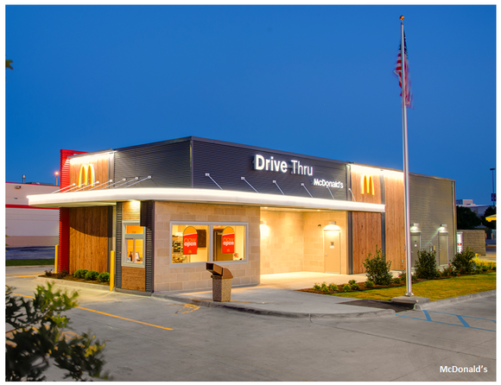

IMAGE SOURCE: MCDONALD'S.

Given that McDonald's is generally considered to be the first fast-food chain to have perfected the drive-through on a large scale, it may come as a surprise that it trailed Wendy's, Burger King, and Yum! Brands' KFC. This may help explain why McDonald's has struggled to increase same-store sales of late, with the figure in the most recent quarter dropping on a year-over-year basis.

Less surprising is the fact that Starbucks is at the bottom of the list. It's never pitched itself as a fast-food company, seeing itself instead as a moderately higher-end coffee shop. Moreover, there's only so much that Starbucks can do ahead of time to prepare mochas and lattes, which require baristas to steam milk and pull espresso shots.

Ultimately, it may not matter much on a relative basis that McDonald's is slightly slower than, say, Wendy's or Burger King. But as fast-food chains struggle to compete against fast-casual chains like **Chipotle Mexican Grill** and **Panera Bread**, there's no question that one element of the formers' value proposition is speed.

**Forget McDonalds: "Total conviction" buy signal issued**The Motley Fool's co-founders, David and Tom Gardner, rarely agree on a stock. But when they do, their picks have beaten the market by 6X on average.*

That's why many investors consider their joint stamp of approval to be a "total conviction" signal to buy. The Motley Fool recently announced a new "total conviction" stock…and it wasn’t McDonalds!