**Starbucks, Dunkin' Donuts Battle for Valentine's Day Hearts**

Both chains have limited-time special products, but they are each using different strategies.

Daniel B. Kline: Feb 8, 2017 at 9:44AM

There was a time when the **Dunkin' Donuts**([NASDAQ:DNKN](https://www.fool.com/quote/nasdaq/dunkin-brands-group/dnkn)) menu barely changed from year to year, let alone seasonally or for each upcoming holiday.

In some ways, the emergence of **Starbucks**([NASDAQ:SBUX](https://www.fool.com/quote/nasdaq/starbucks/sbux)) changed that. The cafe chain has made introducing limited-time beverages (as well as food) an important part of its customer acquisition strategy.

This has worked well for the chain as the return of a favorite like fall's Pumpkin Spice Latte (PSL) or winter's Peppermint Mocha both brings in lapsed fans and gets regulars to spend more money. It's a way for the company to regularly refresh its menu by only adding an ingredient or two to what it already stocks.

Dunkin' has aggressively tried to match its rival. In some cases, like with the PSL, Dunkin' offers its own version, and in others, it's blazing new trails -- such as its iced coffee flavors inspired by ice cream from its sister brand Baskin-Robbins. It's an intense competition that has gotten even more focused over the past few years.

Now, instead of drinks and food staying around for most of a season, Dunkin' has followed Starbucks' lead with even more limited-time offers tied to holidays. These are beverage and food choices that hit menus for just a few weeks (or even a few days) designed to produce a quick spike in consumer interest and demand.

Getting attention for an extremely limited-time offer requires getting inventive. Both chains have done that for Valentine's Day, going head-to-head with new products just for the holiday.

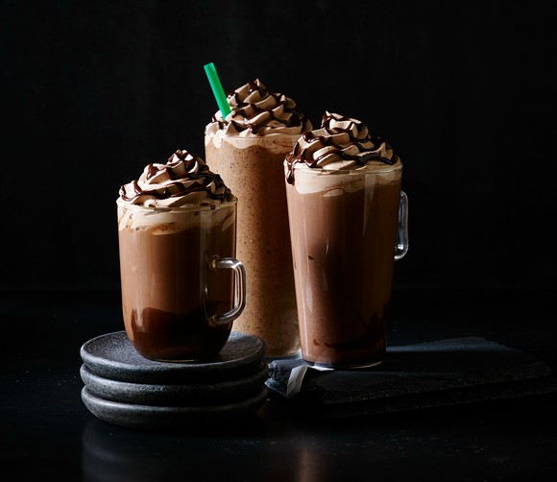

STARBUCKS HAS THREE NEW DRINKS FOR VALENTINE'S DAY. IMAGE SOURCE: STARBUCKS.

**What is Starbucks doing?**

The cafe chain, which tends to make its holiday-themed offers very short in duration has a number of new menu items for the romantic holiday. The company's [Valentine's Day drinks and food items](https://news.starbucks.com/news/valentines-day-2017) launched Feb. 7 and they only run through the holiday on Feb. 14. The drinks all involve chocolate while the limited-time food offers are perhaps less clever:

* **Molten Chocolate Latte:** Served hot or over ice, this one has chocolate chips which are melted into espresso, then topped with steamed milk combined with bittersweet mocha sauce that is then topped with mocha- and espresso-infused whipped cream and an espresso mocha drizzle.
* **Molten Chocolate Frappuccino Blended Beverage:**A mix of coffee with mocha sauce and chocolate chips blended with milk and ice that is finished with mocha- and espresso-infused whipped cream and an espresso mocha drizzle.
* **Molten Hot Chocolate:** Bittersweet mocha sauce and chocolate chips are melted into steamed milk for a smooth and creamy taste, again with mocha and espresso-infused whipped cream along with an espresso mocha drizzle top off the beverage.

The food items consist of a heart-shaped sugar cookie and a Confetti Hearts Cake Pop which the company describes as being its Chocolate Cake Pop with the addition of heart sprinkles. Starbucks also has a number of holiday-themed mugs and gifts on sale.

**What is Dunkin' Donuts doing?**

The coffee and doughnut chain has also already rolled out its holiday menu, but will keep it around through the end of February. Its offering includes two new coffee flavors -- Fudge Brownie Swirl and Vanilla Cupcake -- which can be ordered hot or iced coffees, as well as in lattes and macchiatos. The chain also has a number of pastries that it will be adding to its menu.

* **Chocolate-Covered Raspberry Heart Donut**: A heart-shaped doughnut with raspberry filling, frosted with chocolate icing and drizzled with strawberry-flavored icing
* **Brownie Batter Crumble Heart Donut:**Also a heart-shaped doughnut, this time with brownie batter flavored buttercreme filling, frosted with chocolate icing and sprinkled with brownie crumble
* Fudge Croissant Donut: This is not a new item, but a returning one. It combines a glazed croissant doughnut with fudge filling, topped with chocolate and white icing drizzle

"Valentine's Day is an important and popular holiday for our brand, as our guests look forward to the return of heart-shaped donuts paired with rich, indulgent beverages to celebrate this sweet season," said Dunkin' Executive Chef Jeff Miller in a [press release](https://news.dunkindonuts.com/news/dunkin-donuts-sweet-pairing-for-valentines-day:-heart-shaped-donuts-and-new-fudge-brownie-vanilla-cupcake-flavored-coffees).

**Which company will win?**

Dunkin' has the more innovative food (and heart-shaped doughnuts make for a nice secondary holiday gift) while Starbucks has a stronger beverage lineup. In both cases, the two companies have some compelling choices that should draw in foot traffic.

Starbucks has added urgency to its customer base by keeping its promotion to a single week. That's a risk, but it could create a short-term spike in sales. Dunkin' Donuts is giving its customers more time, allowing people to place repeat orders if they enjoy a product, which could lead to multiple visits or extra spending from someone who comes in regularly anyway.

<https://www.fool.com/investing/2017/02/08/starbucks-dunkin-donuts-battle-for-valentines-day.aspx>