**Canadian fast food test shows Subway poultry contains only around 50 percent or less of chicken DNA, supplemented by soy**

[DAN GUNDERMAN](http://www.nydailynews.com/authors?author=Dan-Gunderman): NEW YORK DAILY NEWS

**Tuesday, February 28, 2017, 10:48 AM**

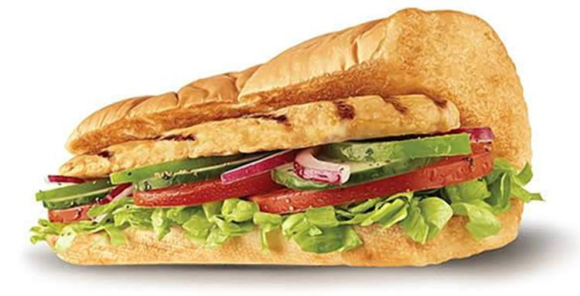

Subway's oven-roasted chicken sub sandwhich. A recent CBC investigation determined that the restaurant's chicken DNA numbers in their popular sandwiches were only around 50 percent. Subway disagreed with the findings.

 (SUBWAY)

**Soy what!?**

A Canadian investigation into the contents in fast-food chicken has shown that Subway’s numbers are quite alarming.

The finding: it’s oven-roasted chicken scored just 53.6 percent chicken DNA and its chicken strips contained just 42.8 percent chicken DNA. The majority of the rest: soy.

The results come from a CBC Marketplace investigation which involved a DNA analysis of poultry from six popular grilled chicken sandwiches and wraps, [CBC reports](http://www.cbc.ca/news/business/marketplace-chicken-fast-food-1.3993967).

The tests were conducted by Matt Harnden, DNA researcher at Trent University’s Wildlife Forensic DNA Laboratory.

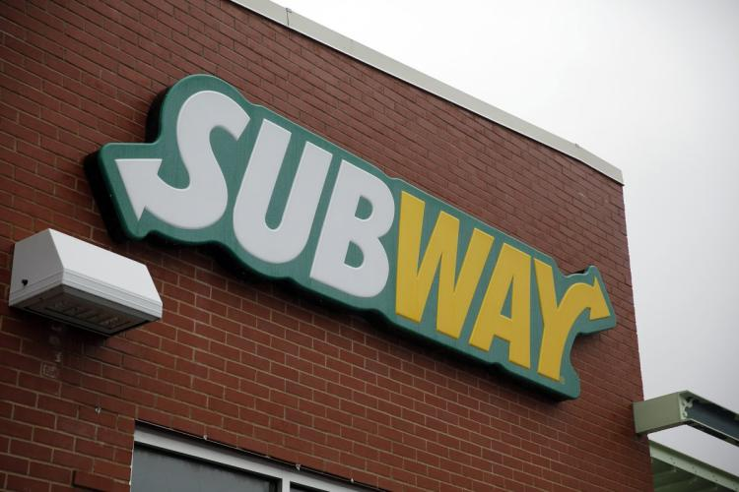

A Subway restaurant in St. Louis, shown on Tuesday, July 7, 2015.

 (JEFF ROBERSON/AP)

A piece of unadulterated chicken from a grocery store should land at 100 percent chicken DNA. Seasoning, marinating or processing the meat lowers that number, so it’s clear that fast food samples would not reach that store-bought benchmark.

Outside of Subway, other restaurants’ numbers were were certainly more normal. A&W’s Chicken Grill Deluxe averaged 89.4 percent chicken DNA, while McDonald’s Country Chicken scored 84.9 percent. Tim Hortons’ Chipotle Chicken Grilled Wrap averaged 86.5 percent and Wendy’s Grilled Chicken Sandwich scored 88.5 percent.

As the results were evaluated, Subway remained an “outlier,” [CBC notes](http://www.cbc.ca/news/business/marketplace-chicken-fast-food-1.3993967), and so researchers tested their meat further.

Once learning of the Subway chicken DNA levels, Irena Valenta, who participated in Marketplace’s taste test, called the sale of the poultry a “misrepresentation.”

In a statement to [CBC](http://www.cbc.ca/news/business/marketplace-chicken-fast-food-1.3993967), Subway said it disagrees with the findings.

“Our recipe calls for one per cent or less of soy protein in our chicken products,” it wrote.

“We will look into this again with our supplier to ensure that the chicken is meeting the high standard we set for all our menu items and ingredients.”

Overall, it was discovered that the fast food chicken in general had nearly a quarter less protein than you’d find in home-cooked chicken. Further, the sodium levels were between seven and 10 times higher than an unadulterated piece.

The tested sandwiches had a combined total of about 50 ingredients in them (an average of 16 each), some of which could be more typical options like honey and onion powder. But Ben Bohrer, a food scientist, also [told CBC](http://www.cbc.ca/news/business/marketplace-chicken-fast-food-1.3993967) that they can contain “industrial ingredients” which are “safe and government approved.”

Some restaurants, such as McDonald’s and Wendy’s, did not disclose what ingredients are used in what proportions, citing them as proprietary, [CBC](http://www.cbc.ca/news/business/marketplace-chicken-fast-food-1.3993967) notes.

<http://www.nydailynews.com/news/world/test-shows-subway-poultry-50-percent-chicken-article-1.2984382>