Grade 10
Time: 60 minutes Total: [75]
___________________________________________________________
Question 1 (20 marks)
State whether the following statements are true of false. If the statement is False, correct it so that it is true.
1.1 The stage in team dynamics where the team briefing usually occurs is the forming stage.
1.2 Forming is the process in teamwork where much disagreement takes place.
1.3 Functional conflict stimulates creativity and allows ideas to flow.
1.4 Mourning follows the success of a team and is a time of celebrating the team’s achievements.
1.5 Synergy is the interaction of two or more people so that their individual
effects are greater than the sum of their combined effect.
1.6 The process of reviewing should only be carried out at the end of the task to evaluate the success of the team.
1.7 An uniform group of people with similar backgrounds will be more creative than a diverse group of people.
1.8 The thinker is the person who has the ideas and is innovative and creative.

Question 2 (10 Marks)
Match the contents of Column A with the most suitable suggestions from Column B
Column A | Column B
2.1 Lack of clarity in roles  2.2 The reason why the team was formed  2.3 Barriers and problems are addressed and solved to enable the team to proceed.  2.4 Disbanding of the group  2.5 A clash of interest or potential for disagreement | a) review  b) performing  c) secondary goal  d) adjourning  e) prejudice  f) norming  g) LTCD method  h) conflict  i) primary goal  j) ambiquity

Question 3 (18 marks)
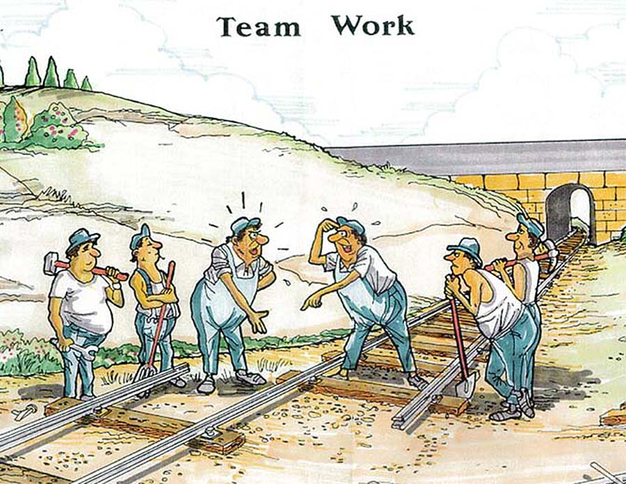
Study the following cartoon and then answer the questions that follow.
The Boss said we must work as a team…
That’s what he always says but then he gives us people like you to work with.

3.1 Classify and explain the type of conflict occurring in the cartoon. (3)
3.2 Mention two factors which could be causing the conflict amongst the railway workers. (4)

3.3 It is evident from the picture that the workers did not work towards a common
goal.
    - Whose responsibility was it to set the goals? (1)
    - Setting goals is not the only important issue to address during the planning process. Explain two other issues that are also important to address during this process. (4)
  - Identify and explain the stage in the team process that this team is currently
at. (3)
  - Discuss the next stage that this team should progress to. (3)
  - There is no “I” in TEAMWORK is one of the most common quotations.
What is your interpretation of this quote? (2)

Question 4 (25 marks)
Read the following case study and answer the questions that follow:
The Briscoe Film Association is a medium entrepreneurial business in the centre of the city. Its main activities are video, film and multimedia production. There are currently 4 teams working on different projects in the business.
The one team has been formed to create an innovative multi-media training program for newly recruited employees for a fast growing leisure company, Mabaso and Mabizela (Pty) Ltd. The managing director of Briscoe Film Association, Rebecca, has asked, Jo Maingard, to look after the project and lead it. However, almost from the start, Jo seemed to have problems. She found it difficult to organise others in the team and often missed deadlines she has set. Rebecca is concerned that the project would not be completed in the two months that they were given.
The other big concern is the morale of the other team members. It is evident that the team is not happy to work with Jo as she is almost always in a bad mood and it seems as if she doesn’t treat people with respect. Last week Jo yelled at one of the team members, Mishka, for being late for work and later commented to another employee that Mishka is useless. The word reached Mishka and she is now threatening to resign and refuses to speak to Jo. Rebecca cannot afford to loose her as she is a very valuable employee.

4.1 What is the primary goal (objective) of the team that Jo is leading? (2)
4.2 What could be a secondary goal (objective) of this team? (1)
4.3 Explain in detail how Rebecca should handle this conflict situation. (8)
4.4 If this project is not completed in time, what will the team experience during the adjourning stage? Explain. (4)
4.5 Advice Rebecca on the important aspects to consider in the execution phase of team work. (10)

