Time: 2 Hours 150 marks

_________________________________________________________________________________

**PLEASE READ THROUGH THE FOLLOWING INSTRUCTIONS CAREFULLY**

1. This paper consists of 8 pages. Please check that your question paper is complete.
2. Read the question carefully and plan the length of your answer in relation to the sections being covered in the question.
3. Candidates are advised to pay special attention to the use of language.
4. It is in your own interest to write legibly and present your work neatly.

|  |
| --- |
| **The following aspects may be considered when marks are allocated in this paper:**  ⮱ Format:   * The **CORRECT** format for each question must be used, e.g. report, letter or dialogue. * Where applicable, include an introduction and conclusion. * Use headings and sub-headings where appropriate.   ⮱ Terminology: Correct Business terminology should be used.  ⮱ Content: Must be sufficient to cover all aspects of the question.  ⮱ Substantiation: Justification for statements made.  ⮱ Application to case study / context.  ⮱ Creative problem solving rather than just giving theoretical facts.  ⮱ Synthesis and appropriate sequencing. |

________________________________________________________________________

**Question 1**

**Refer to the article below and answer the questions that follow:**

**Woolworths: How it all began.**

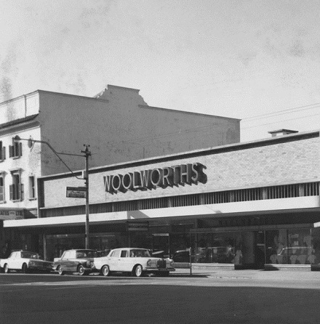

The first Woolworths store opened its doors to the public in Cape Town in October 1931. And it was founder Max Sonnenberg who captured the public’s imagination with dynamic store policies that set Woolworths apart from its competitors.

Three years later, a second branch opened in Durban, with another two in Port Elizabeth and Johannesburg a year later. And since then we’ve been building on our reputation for superior quality, exciting innovation and excellent value.

*Source Adapted:* [*http://www.woolworths.co.za/store/fragments/corporate/*](http://www.woolworths.co.za/store/fragments/corporate/)

1.1 Max Sonnenburg founded Woolworths in 1931.

1.1.1 Discuss the difference between an entrepreneur and an intrapreneur. (4)

1.1.2 Evaluate with the use of **THREE** qualities whether you believe Raymond Ackerman to be an intrapreneur or entrepreneur. (9)

1.2 Explain why entrepreneurship is so important in South Africa. (4)

1.3 All supermarkets within South Africa are directed towards different LSM’s.

1.3.1 What is market research? (2)

1.3.2 Define and discuss what is meant by the term LSM. (3)

1.3.3 Explain which LSM you believe Woolworths to be directed at. (2)

1.4 Critically discuss how an intrapreneur would use the three pillars of triple bottom-line reporting to ensure that Woolworths’ business operations remain sustainable. (12)



1.5 As competition in the South African retail sector is expected to intensify during 2017. Develop a strategy that Woolworths could use to overcome the negative effects of the economic environment of South Africa. (9)



**[45]**

**Question 2**

Creative thinking involves inventive and imaginative thought. Creative thought is

about finding opportunities where less creative thought would not have seen potential. Ideas are the driving force behind successful businesses. Creativity is a way of allowing businesses to recognise and take advantage of opportunities and solve problems.

***Source: Enjoy Business Studies - Heinemann***

2.1 Discuss **four** characteristics that a company like Woolworths would have as an organisation that promotes creative thinking amongst its employees. (8)

2.2 Explain **two** ideas that Woolworths could use to further develop and encourage creativity and ability to think in new ways within their business. (2)

**[10]**

**Question 3**

3.1 Below is a schematic diagram of the business environments in which Woolworths operates.

Provide the answers to the following questions on the diagram below.

3.1.1 Identify the business environments, (one has been done for you). (2)

3.1.2 List any TWO elements found in each environment and discuss how each of those elements would have an effect on Woolworths. (12)

3.1.3 State how much control Woolworths has over each business environment. (3)

3.1.4 Choose any TWO variables/elements that you have listed above and explain how changes in these variable could affect Woolworths’ decision making. (4)

3.1.5 Because an economy is such a complex system, there are other ways of looking at economic sectors.

Distinguish between the following sectors:

4.1.5.1 The formal and the informal sectors of the economy. (2)

4.1.5.2 The private and public sectors of the economy. (2)

4.1.5.3 In which sectors (mentioned in 4.1.5.1 and 4.1.5.2) does Woolworths operate? (2)

**[25]**

**Question 5**

Within South Africa, companies like Woolworths are affected by a number of socio-economic issues.

Identify **four** of these issues, discussing each one briefly and also explaining the impact of each on Woolworths in the current economic environment. Furthermore, provide strategies on how Woolworths can continue to grow and achieve sustainability whilst facing these challenges. (12)

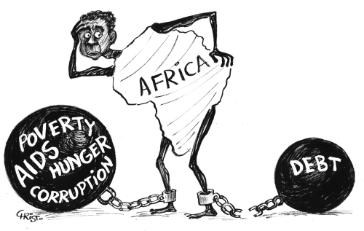

**[12]**

**Question 6**

Discuss how a manager in Woolworths could use the information gained from the WRewards card to influence the behaviour of its target market. (4)



**[4]**

**Question 7**

Study the source below. Identify an opportunity in Woolworths’ market environment and discuss how Woolworths could use two of the factors of production identified below, to respond to the opportunity identified. (4)

# http://i.ytimg.com/vi/VZD7dTSHmIo/maxresdefault.jpg

**[4]**

**Total Section B: 100 marks**

**Question 8**

**Study the following sources and then answer the question that follows.**

**Woolworths sees tough year in SA**

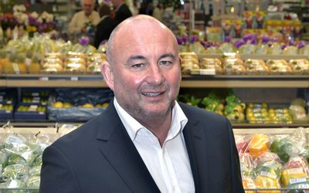

South African food and clothing retailer Woolworths said weaker consumer spending and economic growth would make trading conditions more difficult this year in both its Australian and domestic market.

“It’s going to get tougher in South Africa,” Chief Executive Officer Ian Moir said on a conference call from Cape Town on Thursday. “I think we will take market share, but we need to keep on top of costs.”

[***Food sales feed Woolworths' earnings***](http://www.iol.co.za/business/companies/food-sales-feed-woolworths-earnings-1982861)

South African retailers and consumer spending are under pressure as the country’s worst drought in more than a century pushes prices higher, with December food inflation climbing to 5.8 percent. Meanwhile a weakening rand against the dollar prompted the central bank to raise interest rates by half a percentage point last month, increasing repayment costs for those with loans or mortgages.

“Increasing interest rates in South Africa will add further pressure on the local consumer,” Woolworths said.

Woolworths shares, which rallied 30 percent in 2015, fell as much as 7.8 percent in Johannesburg, the biggest fall since December 11, and traded 6.7 percent lower at 87 rand as of 9.18am local time. The stock has dropped 12 percent this year, in line with the fall on the FTSE/JSE Africa General Retailers Index.

David Jones, bought for $2 billion in 2014, is performing “well ahead of expectations”, Moir said. The company’s total food-sales performance was better than the market average, he said, even as prices rose by 5.7 percent in the second half of last year.

Woolworths also benefits from the rand’s depreciation relative to the Australian dollar, a result of purchase of Sydney-based David Jones. The rand has weakened about 26 percent against the Australian currency during the past year. The company will pay an interim dividend of R1.33, an increase of 38 percent.

***http://www.iol.co.za/business/companies/woolworths***

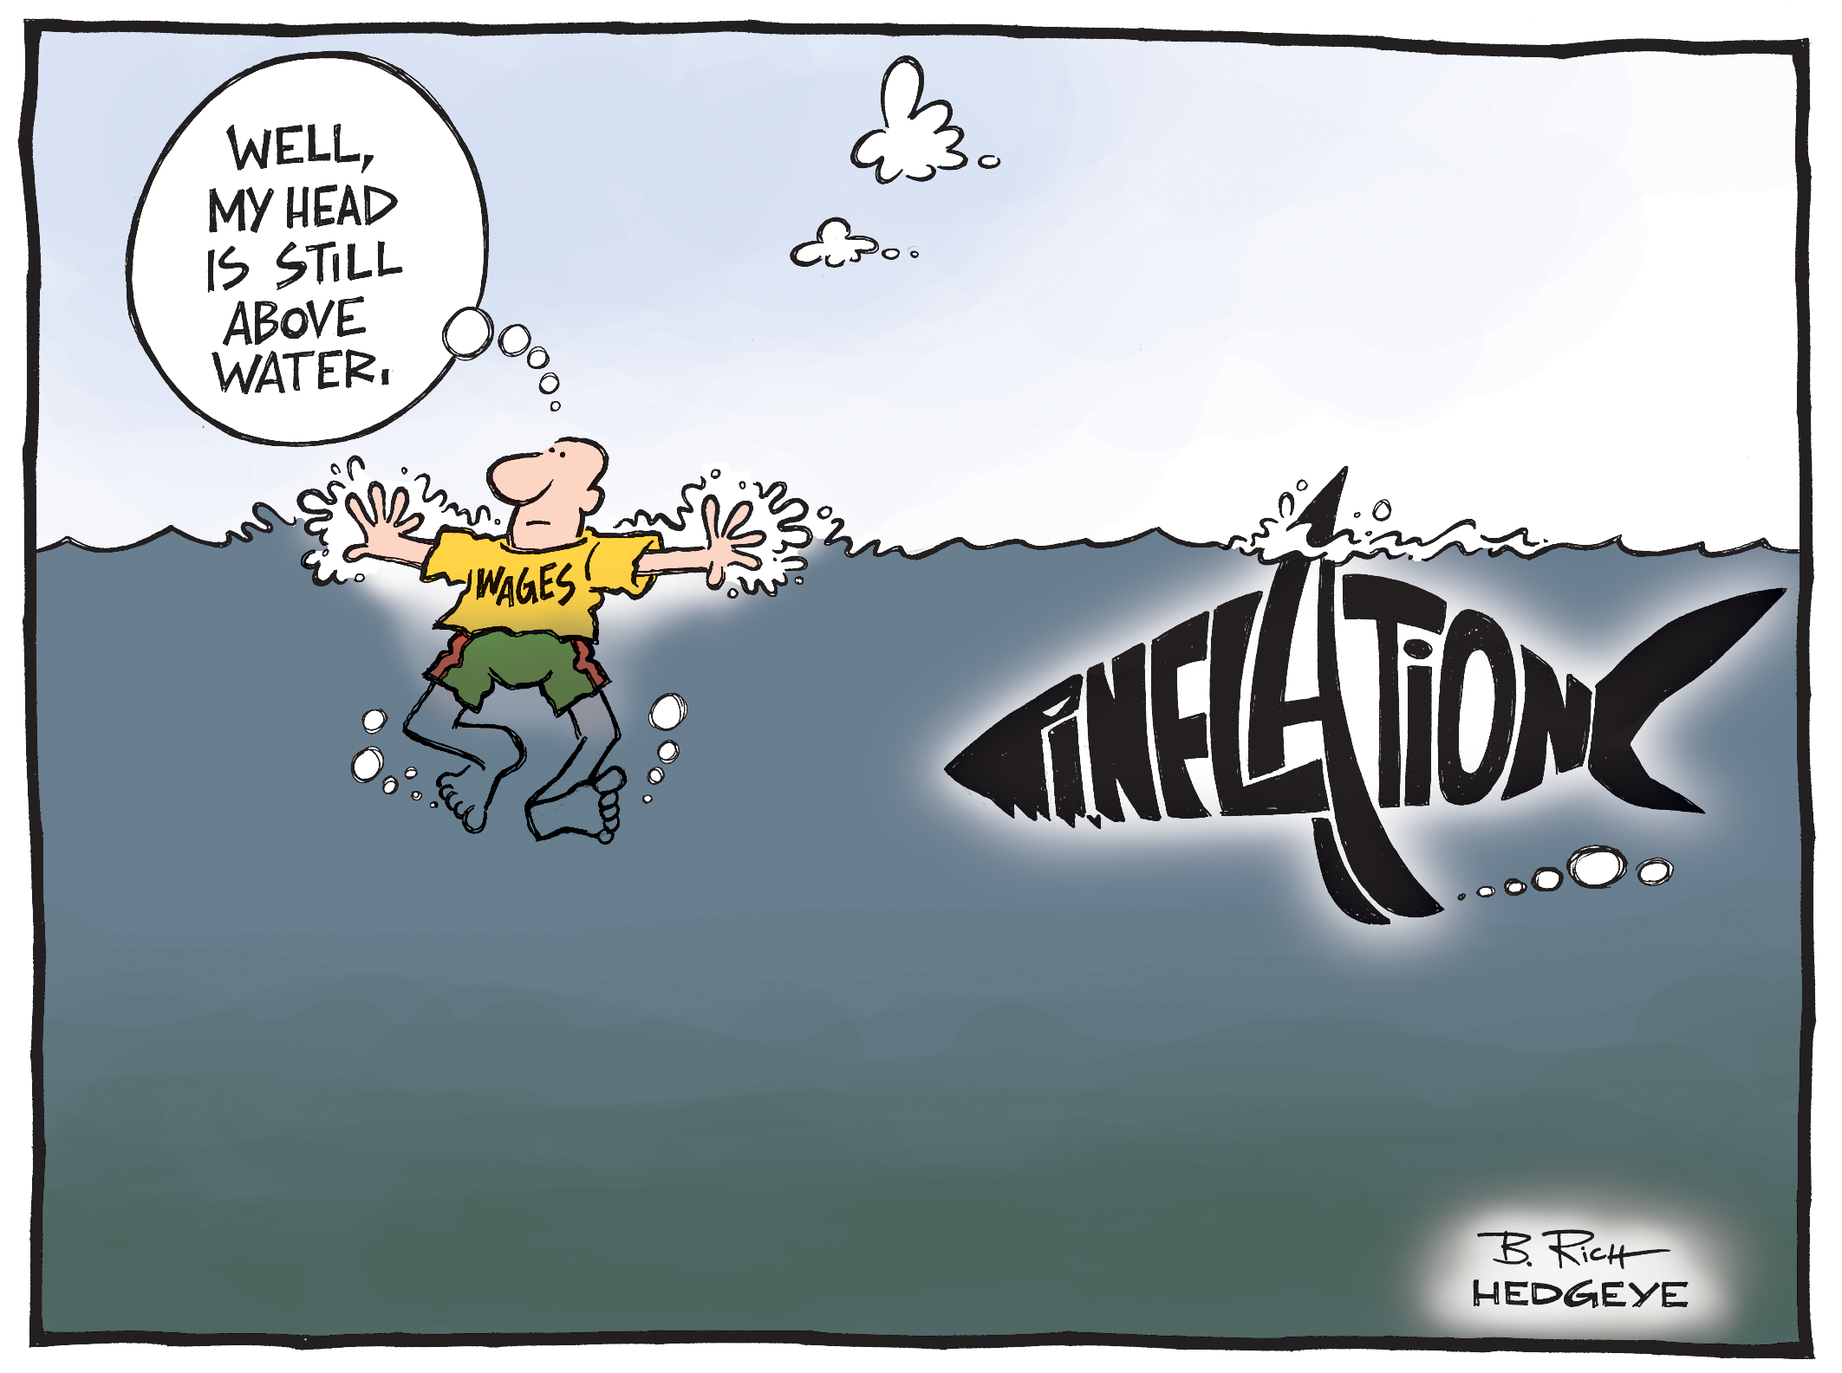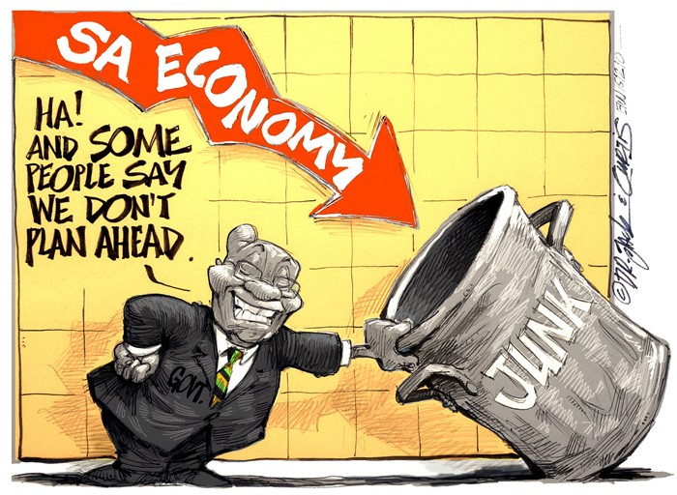



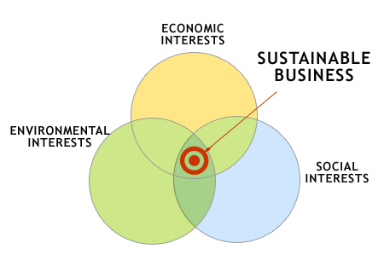

**Required:**

Use the sources above to help you identify the macro environmental elements that could have an impact on Woolworths’ micro environment. With the use of the strengths and weaknesses analysis, assess how Woolworths could use entrepreneurial qualities to over-come the challenges from the external business environment.

Furthermore, help Woolworths understand how management could use the strengths and weaknesses in ensuring that the business is sustainable.

(50)

**Total Section B: 50 marks**

**Total Exam: 200 marks**