GRADE 10
JUNE: PAPER II

Time: 2 hours 100 marks

PLEASE READ THESE INSTRUCTIONS CAREFULLY.

- This paper consists of 3 pages, including this front page. Check that your paper is complete.

- The paper comprises TWO longer type questions. You must answer BOTH.

- Read the questions carefully and plan the length of your answers in relation to the marks
allocated for each question. Take time to plan answers, e.g. 15 minutes planning and 45
minutes writing.

- Refer to the case study and examples relevant to the case study where applicable.

6. Demonstrate insight, where applicable, and use your own word when answering
questions.

7. Answer each new question on a new page.

8. Number your answers as the questions are numbered on the question paper.

9. Candidates are advised to pay particular attention to the use of language and relevant Business terminology.

10. It is in your interest to write legibly and present your work neatly.

QUESTION 1 [50]
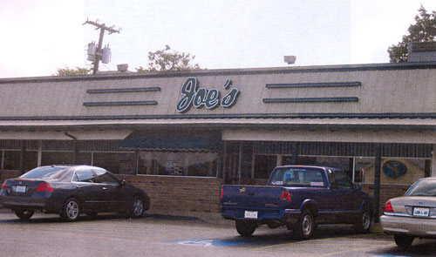
Joe Sadowski, founder of Joe’s Coffee Shop, would like to expand his business to KZN. He would like to open a coffee shop somewhere in Durban. Sandra Young is a prospective Joe’s Coffee Shop franchisee. She is busy preparing her business plan and requires assistance on deciding where to locate her new business. She does not know Durban very well and does not want to take the risk of failure. She also needs advise on possible challenges in the macro-environment.

Required:

You are a Market Analyst who advertised your abilities on the internet. Sandra contacts you to do an environmental study and a market research for her. You reply by writing Sandra a business letter in which you include:

- A PESTLE analysis for the business environment and how macro factors would impact on her business in Durban.
- The factors she must consider when choosing a location and recommend possible 'hot spots' in Durban.
- Write the Marketing analysis and marketing plan section of her Business Plan for her, including an example of a market research questionnaire, comprising of at least six questions.

50 marks

QUESTION 2 [50]


You are the marketing manager appointed by Joe to run marketing campaigns for him in KZN. Joe asked you to include school trips in your marketing campaign.

Required:

The topics that you were asked to discuss in a business report are:

- 'The route a product follows through the sectors of economy'.
- How Joe's coffee shop uses their internal strengths to have an advantage over competitors. (This can include any micro environmental factors as well as team performance criteria)

50 marks

