**Paper I**

## __________________________________________________

**Time:** One Hour **Total**: 100 Marks

_________________________________________________________________________

## PLEASE READ THE FOLLOWING INSTRUCTIONS CAREFULLY

1. This paper consists of 6 pages. Please check that your question paper is complete.
2. Read the question carefully and plan the length of your answer in relation to the sections being covered in the question.
3. Candidates are advised to pay special attention to the use of language.
4. It is in your own interest to write legibly and present your work neatly.

|  |
| --- |
| The following aspects may be considered when marks are allocated in this paper:  ⮱ Terminology: Correct Business terminology should be used.  ⮱ Content: Must be sufficient to cover all aspects of the question.  ⮱ Substantiation: Justification for statements made.  ⮱ Application to case study / context.  ⮱ Creative problem solving rather than just giving theoretical facts.  ⮱ Synthesis and appropriate sequencing. |

# Question 1:

Indicate the most correct answer by writing the letter of your choice next to the corresponding number.

|  |  |  |
| --- | --- | --- |
| 1.1 |  | The aim of insurance is to …… |
|  | A | Prevent underinsurance |
|  | B | Protect against financial loss |
|  | C | Promote insurance |
|  | D | Adjust premiums to inflation |
|  |  |  |
| 1.2 |  | Insurable interest is applicable when |
|  |  | (i) a person has an interest in his own life |
|  |  | (ii) a debtor has an interest in the life of a creditor |
|  |  | (iii) a partner has an interest in the life of his co-partner |
|  |  | (iv) a mortgager has an interest in the property of the person taking out the mortgage |
|  |  |  |
|  | A | (i), (ii) and (iii) |
|  | B | (i), (ii) and (iv) |
|  | C | (i), (iii) and (iv) |
|  | D | All the above-mentioned |
|  |  |  |
| 1.3 |  | … applies when the right to claim against a guilty party is transferred to the insurer after he (the insurer) had compensated the insured. |
|  | A | Reinsurance |
|  | B | Contribution |
|  | C | Subrogation |
|  | D | Cession |
|  |  |  |

[](https://www.google.co.za/url?sa=i&rct=j&q=&esrc=s&source=images&cd=&cad=rja&uact=8&ved=0ahUKEwirid36w9rKAhUGWRQKHQ5XAxoQjRwIBw&url=http://www.tipinsurance.xyz/&psig=AFQjCNH3V2nQ9w8C4bgtY5krF28RMCS6XQ&ust=1454552339910379) (6)

# Question 2:

All of the following statements are FALSE. Replace the underlined word with the correct word to make the statement TRUE. Write only the word next to the question number.

|  |  |
| --- | --- |
| 2.1 | **Cession** gives the insurer the option to replace damaged goods instead of paying out a cash amount. |
| 2.2 | **COIDA** covers employees against loss of income if they do not have a job. |
| 2.3 | **Fidelity insurance** occurs when a business contributes 1% and the employee contributes 1% equal to the employee’s salary to an insurance |
| 2.4 | **Trauma Cover** is taken out to insure against the risk of the loss of a limb. |
| 2.5 | **Insurance** is taken out as cover for a risk that is certain. |

(5)

**Question 3:**

Define each of the following terms **and** briefly discuss how each of these terms could have an impact on Mr Price’s performance.

|  |  |
| --- | --- |
| 3.1 | Endowment |
| 3.2 | Market Share |
| 3.3 | Absolute Honesty |
| 3.4 | Bonds |
| 3.5 | Offshore Investments |

(10)

**[21 marks]**

[](https://www.google.co.za/url?sa=i&rct=j&q=&esrc=s&source=images&cd=&cad=rja&uact=8&ved=0ahUKEwiygcKixNrKAhUHXRQKHWb6BkYQjRwIBw&url=http://www.mrpricegroupcareers.com/&bvm=bv.113034660,d.d24&psig=AFQjCNE6S1aEOeYFJk4kPps60KKlJ1_rHQ&ust=1454552447818025)

**Question 4:**

**Read the following case study then answer the questions that follow:**

|  |
| --- |
| Mr Price plunges on slower sales RETAILER Mr Price Group’s shares lost nearly 18% on Friday.  The share price fell 17.82% to close at R156.96.  Investors had had high growth expectations for the retailer.  The slow growth can be clearly seen in the Mr Price share price reaction.  The trading environment continues to be challenge.  Cash sales, which constitute 83.2% of total group sales, grew 8.3%. Credit sales, meanwhile, declined by 1.4%, with the company citing strict credit granting criteria, consumers’ low credit appetite and recent legislative changes affecting new account applications.  Mr Norman-Smith said Mr Price and other South African retailers were facing increasing competition from abroad, which would weigh on their performances.  Massive profits generated in the retail sector over the past decade have attracted significant competition. This going pressure on profits at a time when the local consumer is under pressure, is a dangerous combination, which is likely to make it very difficult for local players to repeat their recent growth in the coming years.  Source adapted from: [http://www.bdlive.co.za/business/retail/2016/01/18/mr-price-plunges-on-slower-sales 02/02/2016](http://www.bdlive.co.za/business/retail/2016/01/18/mr-price-plunges-on-slower-sales%2002/02/2016) |

4.1 Discuss how Mr Price’s market environment could have contributed to the slow growth experienced by Mr Price. Make use of any three elements of the Porters Five Force tool in your analysis of the environment.

(9)

4.2 Explain how Mr Price could make use of a value chain analysis to encourage growth and create a competitive advantage in a market place that is experiencing a decline.

(6)

4.3 Complete a SWOT analysis where you identify two of Mr Price’s weaknesses. Discuss how these weaknesses could contribute to further sales decline if they are not addressed.

[](https://www.google.co.za/url?sa=i&rct=j&q=&esrc=s&source=images&cd=&cad=rja&uact=8&ved=0ahUKEwiQzp-txNrKAhVB2hQKHdNNAn0QjRwIBw&url=http://www.mrp.com/&bvm=bv.113034660,d.d24&psig=AFQjCNE6S1aEOeYFJk4kPps60KKlJ1_rHQ&ust=1454552447818025)(6)

**[21 marks]**

**Question 5:**

**Study the following diagram and answer the questions that follows:**

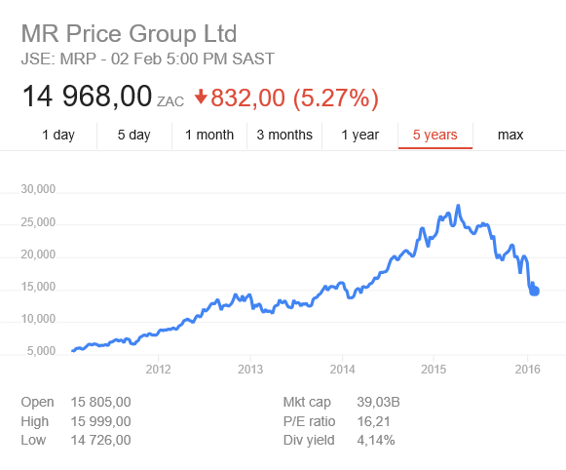

5.1 Describe the market environment experienced by Mr Price between 2012-2015.

(2)

5.2 What is meant by the term market capitalization?

(1)

5.3 Discuss Mr Price share by referring to Risk, ROI and Time.

(6)

5.4 Assess how Mr Price could use debentures to encourage market growth.

(3)

5.5 Discuss the following investment strategies:

* Growth Investment Strategy
* Conservative Investment Strategy
* Balanced Investment Strategy

(9)

5.6 Assess how the economic and legal elements of the PESTLE analysis could impact on investors’ decisions when thinking of investing in Mr Price.

(6)

**[27 marks]**

**Question 6:**

[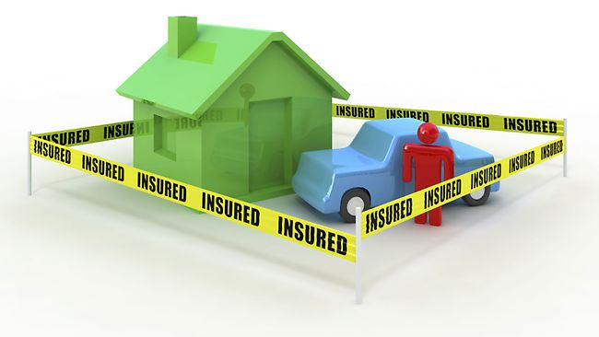](https://www.google.co.za/url?sa=i&rct=j&q=&esrc=s&source=images&cd=&cad=rja&uact=8&ved=0ahUKEwis_7GE1NnKAhVHThQKHchaDjkQjRwIBw&url=http://trustinsurancequotes.com/&bvm=bv.113034660,d.cWw&psig=AFQjCNEE2I3jl8dk8nEeISb4DxvXxYHPgA&ust=1454522261062109)**Study the following sources and answer the questions that follows.**

[](https://www.google.co.za/url?sa=i&rct=j&q=&esrc=s&source=images&cd=&cad=rja&uact=8&ved=&url=http://bchlife.com/insurance-for-your-clients-retirement-portfolio/&bvm=bv.113034660,d.cWw&psig=AFQjCNEE2I3jl8dk8nEeISb4DxvXxYHPgA&ust=1454522261062109)

[](https://www.google.co.za/url?sa=i&rct=j&q=&esrc=s&source=images&cd=&cad=rja&uact=8&ved=0ahUKEwiXnN771NnKAhWK1xQKHUqiDmUQjRwIBw&url=http://lawyersinsurance-info.com/2016/01/14/insurance-that-you-may-not-know/&bvm=bv.113034660,d.cWw&psig=AFQjCNEE2I3jl8dk8nEeISb4DxvXxYHPgA&ust=1454522261062109)[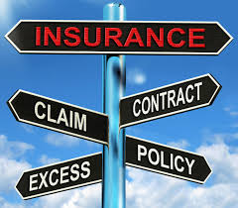](https://www.google.co.za/imgres?imgurl=http://motivationalletter.com/wp-content/uploads/2016/01/insurance.jpg&imgrefurl=http://motivationalletter.com/motivation-letter-sample-for-insurance-claims-officer/&h=1308&w=1492&tbnid=qko_KsEBH1tKOM:&docid=uHMWc8WZY3IJ6M&ei=FO6wVpDYJovc-QH9t5ioDA&tbm=isch&ved=0ahUKEwiQssnm09nKAhULbj4KHf0bBsUQMwiZAShiMGI)

6.1 Differentiate between insurance and assurance.

(2)

6.2 Names and discuss two compulsory insurances.

(6)

6.3 Explain how the compulsory insurances in question 6.2 would apply to Mr Price.

(4)

6.4 Discuss the requirements for a valid insurance contact.

(6)

6.5 Explain the link between risk and premium.

(4)

6.6 Name three types of non-compulsory insurance. Also assess the need for each of these insurances from Mr Price’s point of view.

(9)

**[31 marks]**

**[Total: 100 marks]**

[](https://www.google.co.za/imgres?imgurl=http://www.mycitybynight.co.za/wp-content/uploads/2012/06/Mr-price-logo.jpg&imgrefurl=http://www.mycitybynight.co.za/mr-price-do-infants-make-your-shoes/mr-price-logo/&h=93&w=448&tbnid=9KmjDMMXu5guKM:&docid=aMfJc5ix9mDOZM&ei=_2OxVs3fHsG7UdfGneAE&tbm=isch&ved=0ahUKEwiN2-WgxNrKAhXBXRQKHVdjB0wQMwhcKCUwJQ)