Time: 1 Hours 50 marks

_______________________________________________________________________________________

**PEASE READ THE FOLLOWING INSTRUCTIONS CAREFULLY**

1. This paper consists of 3 pages. Please check that your question paper is complete.
2. Read the question carefully and plan the length of your answer in relation to the sections being covered in the question.
3. Candidates are advised to pay special attention to the use of language.
4. It is in your own interest to write legibly and present your work neatly.

|  |
| --- |
| The following aspects may be considered when marks are allocated in this paper:  ⮱ Format:   * The CORRECT format for each question must be used, e.g. report, letter or dialogue. * Where applicable, include an introduction and conclusion. * Use headings and sub-headings where appropriate.   ⮱ Terminology: Correct Business terminology should be used.  ⮱ Content: Must be sufficient to cover all aspects of the question.  ⮱ Substantiation: Justification for statements made.  ⮱ Application to case study / context.  ⮱ Creative problem solving rather than just giving theoretical facts.  ⮱ Synthesis and appropriate sequencing. |

_______________________________________________________________________________

**Question 1:**

**Read the following case study and then answer the question that follows:**

|  |
| --- |
| **Santie Botha, Independent Chairman of Famous Brands, states in the integrated report:**  “We anticipate that the difficult trading conditions experienced this year will persist and possibly intensify. Subdued economic growth, political uncertainty, labour unrest and increased living costs will have a negative impact on consumer sentiment and spend, and retailers will need to compete fiercely to achieve real growth. I am satisfied that Famous Brands’ investment proposition, centred on providing a holistic solution to investment partners and consumers, together with its planned strategic initiatives aimed at boosting growth position the Group well to optimally manage future adverse conditions.” |

|  |
| --- |
| **Vision**  To become Africa’s first choice branded food services Franchisor.  **Strategic intent**  Our business is focused on building capability across brands, logistics and manufacturing, which provides a total solution to our investment partners and consumers.  [http://www.famousbrands.co.za/includes/nav/img/logo2.png](http://www.google.co.za/url?sa=i&rct=j&q=&esrc=s&frm=1&source=images&cd=&cad=rja&uact=8&docid=OrqpxnugokBLnM&tbnid=BV2YeEgrct6m0M:&ved=0CAUQjRw&url=http://www.famousbrands.co.za/&ei=Sm27U7LwAubF0QXZxICYBg&bvm=bv.70138588,d.ZGU&psig=AFQjCNE9oWpsOoEiHEkGUPY4SvIt0RzCCg&ust=1404878523417363)**Core beliefs**  > Champions  > Quality  > Innovation  > Speed  > Agility  > Integrity  > Humility  **(Source: Integrated Report 2015)** |

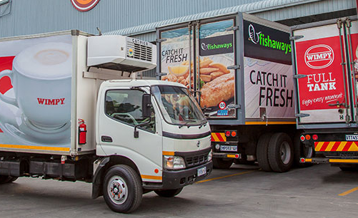

**Required:**

Famous Brands continues to work towards it goals, by ensuring that its action plans are aligned to meet the business: Vision, Strategic Intent and Core Beliefs.

It is important that the business does not under-estimate the challenges from the different business environments.

Write a business report in which you help Famous Brands understand the challenges from the external environment of the business. With the use of the SWOT analysis, assess how Famous Brands could over-come challenges from the external business environment.

It is also important to ensure that Famous Brands remains the choice Fast Food Franchisor by ensuring that what they deliver to all its stakeholders is differentiated and innovative. Asses how an intrapreneurial spirit could be used to deliver differentiated and innovation products/ideas/solutions etc, to the various stakeholder groups.

**[50 Marks]**

[](http://www.google.co.za/url?sa=i&rct=j&q=&esrc=s&frm=1&source=images&cd=&cad=rja&uact=8&docid=GTjjB_VSXhJQfM&tbnid=bBL3oXzR0y41TM:&ved=0CAUQjRw&url=http://www.lrssa.com/case-study-famous-brands.html&ei=3RO9U-KqBeae7AbI44CIAg&bvm=bv.70138588,d.ZGU&psig=AFQjCNGNWeh2tOoOTeKSvfaiAorKLUPazg&ust=1404986708957741)