**Business Studies: Paper II**

## __________________________________________________

**Time:** 1 hour **Total**: 50 marks

_________________________________________________________________________

## PLEASE READ THE FOLLOWING INSTRUCTIONS CAREFULLY

1. This paper consists of 3 pages. Please check that your question paper is complete.
2. Read the question carefully and plan the length of your answer in relation to the sections being covered in the question.
3. Candidates are advised to pay special attention to the use of language.
4. It is in your own interest to write legibly and present your work neatly.

|  |
| --- |
| The following aspects may be considered when marks are allocated in this paper:  ⮱ Format:   * The CORRECT format for each question must be used, e.g. report, letter or dialogue. * Where applicable, include an introduction and conclusion. * Use headings and sub-headings where appropriate.   ⮱ Terminology: Correct Business terminology should be used.  ⮱ Content: Must be sufficient to cover all aspects of the question.  ⮱ Substantiation: Justification for statements made.  ⮱ Application to case study / context.  ⮱ Creative problem solving rather than just giving theoretical facts.  ⮱ Synthesis and appropriate sequencing. |

**QUESTION 1**

**Read the article and then answer the question that follows**

# Retail: Nice at the price?

“For years, Mr Price’s philosophy was to provide designer fashion at an affordable price. It got them a prime slice of that higher income market, and it worked exceedingly well,” says Abraham-Stock Analysts.

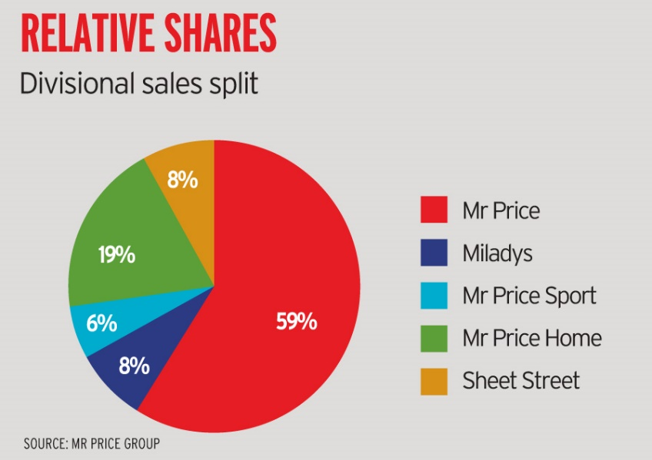Six months ago, the SA Customer Satisfaction index showed Mr Price had dropped to fifth place behind Woolworths, Ackermans, Pep and Truworths.

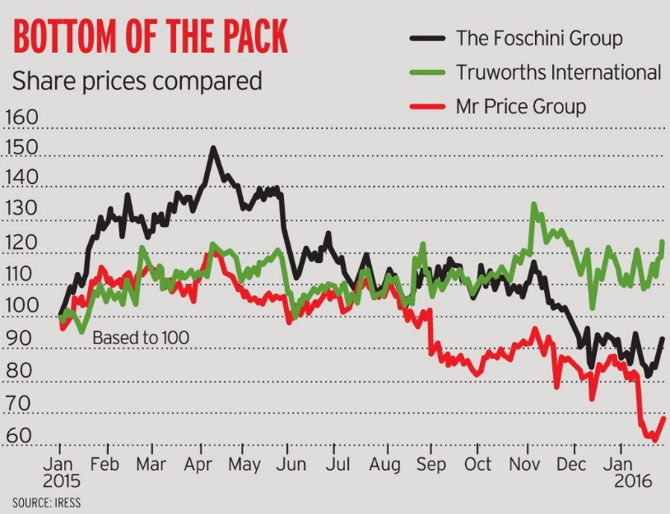

CEO Stuart Bird says the share price dive surprised him, since he was “pretty satisfied” with the way business was working.

Overall, sales had risen 6.5% — but that included inflation of 6.6% on the products themselves. Stripping out new stores, sales were actually down 3.2% at comparable stores.

“We did have some areas that could have done better and some delivery issues, but this is not unusual in the fashion business and, as we have in the past, we will work hard to get them back in line,” Says Stuart Bird.

“The apparel business is all about three things: product, product and product.” The stuff has to be well constructed, offer value at the right price and appeal to customers.

“There is clearly something wrong with some of Mr Price’s product offerings. Consumers liked other retailers’ products more.”

Importantly, Bird and finance director Mark Blair have admitted Mr Price erred on some fashion calls. This is inevitable in the fashion business, Bird says. “It can and will probably happen again. Unless you are taking risks in fashion you are not in the game.”

The thing is, Mr Price didn’t just choose the wrong clothes ranges. There were also shortages at critical times in items like men’s chinos, and blunders of timing in its release of other products.

(Source adapted from: <http://www.financialmail.co.za/coverstory/2016/02/04/retail-nice-at-the-price> 26/04/2016)

A business like Mr Price needs to ensure that they are always ahead of their competitors. It is thus important that the focus on the overall performance of the business- to ensure that all aspects of the business is driving scares factors of production towards the vision of the business. The Business will also need to ensure sound management of these resources.

**Required:**

You have been asked to write a business report to Mr Price in which you assess the overall performance of Mr Price with the use of the Balanced Score Card. Also identify possible weaknesses and threats that could affect the overall performance of Mr Price, with the use of the following: management tasks, management competencies and leadership styles create strategies that could be adopted by Mr Price to overcome these negative influences.

**[50 marks]**

