**BUSINESS STUDIES**

Add school badge

**Grade 12 –Portfolio 2016**

**Set by: D Prinsloo**

**Moderated by:**

**Oral**

**Instructions:**

1. ***Plagiarism will be penalised to the full extent. All plagiarised sections of work will not be marked or considered part of the task.*** ***90% of the text must be written by you and a maximum of 10% may be directly quoted and cited. All direct quotations must be correctly cited and referenced (Harvard referencing format)***
2. ***Submit an anti-plagiarism and authenticity statement with an anti-plagiarism checking certificate (e.g. plagtracker) attached to the back of your assignment.***

1. This task forms 15% of your final portfolio mark, so allocate your time and effort accordingly.
2. All late work will be penalised according to the school policy.
3. It is recommended that you use a variety of at least *three* alternate sources to complete the task.
4. All sources need to be referenced correctly.
5. Your task (slides and talk) must be submitted on ***CD as well as a hardcopy***!
6. Presentation requirements:
   * This is an individual task.
   * The power point must be professionally presented, no long paragraphs on the slides!
   * Insert all the necessary extras onto the slides to ensure it is of the correct standard.
   * You must submit a typed copy of your speech, this must be a full account of your talk.
   * You must submit a printout of your slides. NB: There must be a minimum of 6 slides printed per one page – colour not necessary.
   * Work must be stapled on the top left hand corner when handing in.
   * Place your work in one plastic sleeve along with the CD (Please mark you CD clearly).
7. Please make reference to the attached Rubric when preparing your oral as to include every aspect expected of you.

***Task:***

Choose any subsidiary of Mr Price Group Limited and discuss their corporate social responsibility programmes and their corporate governance policies. Include a background of the chosen company.

You are expected to present your ± 3-5 minute presentation in the appropriate manner, you need to have a well-planned slide show to accompany your speech. All other forms of media are welcome, yet optional.



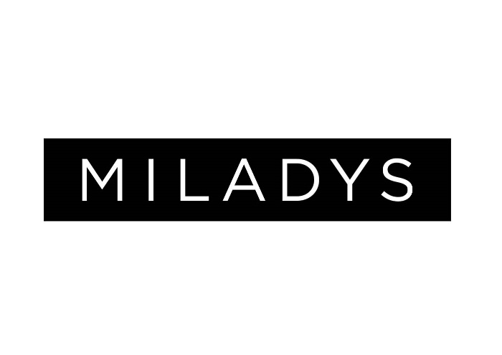



|  |  |  |  |  |  |
| --- | --- | --- | --- | --- | --- |
| **RUBRIC – ‘Corporate governance’**  STUDENTS  MARK: 50  50  NAME: _______________________________________ | | | | | |
|  | 0-2 | 3-5 | 6-8 | 9-10 | Total |
| QUALITY OF DELIVERY | | | | | |
| Presentation - Communication  [LOT] | (0) Not. (1&2)Partially meeting the standard of correct articulation, proper preparation, eye contact etc. | (3)Adhering to presentation criteria of public speaking (4) in a business environment (5) and dynamic | Good to very good meeting the criteria of public speaking(6), good posture and eye contact(7), The use of visual aids and correct language use(8). | Superbly meeting the criteria of public speaking, good posture and eye contact (9), The use of visual aids and correct language use (10). |  |
| QUALITY OF PRESENTATION | | | | | |
| Presentation – Media aspects  [LOT] | (0) Not. (1&2)Partially meeting the standard of a well execute power point. (Slides numbered, logos, correct colour contrasts etc.) | Adequately presented power point (3) meeting all criteria (4) limited additional media (5) | Professionally presented power point (6) meeting all criteria well (7) as well as additional media used correctly (8). | Outstandingly presented power point meeting all criteria well as well as more than one additional media used correctly (9&10). |  |
| QUALITY OF CONTENT | | | | | |
| Background of the company?  [LOT] | (0) No to (1&2) limited detail in the Research of the background of the company. | (3) Adequate to (4 &5) good detail in the Research of the background of the company. | (6) Satisfactory to (7 &8) good detail in the Research of the background of the company. | Excellent detail in the Research of the background of the company. (9&10) |  |
| King Codes  [HOT] | (0) King code aspects not identified (1) aspects identified but not understood (2) aspects identified in minimal detail. | (3) Adequate detail identified relating to King codes (4) All three codes mentioned in limited detail (5) Codes mentioned correctly with minimal application | (6) Codes mentioned with fair application (7&8) codes applied in good detail. | (9&10) King codes discussed with outstanding detail and application, showing breadth and depth of understanding. |  |
| Characteristics of good governance & sustainability  [HOT] | (0) Not included (1&2) Characteristics & sustainability identified but not understood | (3) Mentioned one of the topics - characteristics or sustainability (4 &5) mentioned both in limited detail. | (6) Satisfactory to (7 &8) good detail on both characteristics and sustainability | Excellent detail and application of both the characteristics and good governance. (9&10) |  |
| TOTAL: **(50MARKS)** | | | | | |

**Educator & Date**

Comments:_____________________________________________________________________________________________________________________________________________________________________________________________________________________________________________________________________________________________

|  |  |  |  |  |
| --- | --- | --- | --- | --- |
| Add school badge    **BUSINESS STUDIES**  **Portfolio 2016** | | | | |
| **STATEMENT OF AUTHENTICITY** | | | | |
| Centre Number |  | Examination number | |  |
| ***DECLARATION BY THE CANDIDATE*** | | | | |
| I, __________________________________________________________ (print full names) declare that all external sources used in my SBA have been properly referenced and that the remaining work contained in this SBA is my own original work. I understand what plagiarism is, and accept the Plagiarism Policy of [Name of School] in this regard. I have also not allowed anyone to borrow or copy from my work. I understand that if this is found to be untrue, my SBA will be liable for disqualification. | | | | |
| Signed: | Candidate | Date: |  | |
| ***DECLARATION BY THE CANDIDATE’S EDUCATOR:*** | | | | |
| I ______________________________________________ (print name and title of  Educator) at ________________________________________________ (print name of school) declare that the work provided by this candidate has been monitored and checked for plagiarism. | | | | |
| Signed: | Educator | Date: | |  |