**Business Studies**

**Worksheet: Business Ethics**

**TOP Three Unethical Business Practices**

This list was originally titled “Most Evil Corporations”. As long as there has been big-business there have been suspicious and immoral actions taking place to preserve profit, market share and public image. This list cannot be ranked too effectively, as the extent and severity of the misdeeds cannot be measured, but the items have been chosen because of their human and long-term cultural impact.

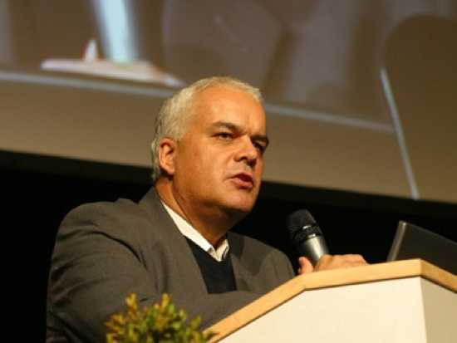**NUMBER 3 Matthias Rath -** Alternative treatments for HIV/AIDS

Matthias Rath is a doctor turned vitamin entrepreneur. He runs the Dr. Rath Health Foundation and founded the Dr. Rath Research Institute. He has been called “the most powerful crackpot on the Earth” due to the large amount of funds he has gotten from investors who can see the value of selling “vitamin pills” to cure the most serious of ailments.

In the UK, his adverts claimed that “90 per cent of patients receiving chemotherapy for cancer die within months of starting treatment”, and suggested that three million lives could be saved if cancer patients stopped being treated by conventional medicine. The pharmaceutical industry was deliberately letting people die for financial gain, he explained. These advertisements are highly detrimental to cancer sufferers and cancer research groups, it can be easy to look at someone who has lost all their hair to chemotherapy and think that it is a poison, but it is scientifically proven to fight cancer.

Before advertising standards agencies from all over Europe were finally able to stop some of the dishonest adverts (challenging alternative medicine claims are always difficult due to the very nature of the topic), Rath had made his fortune and walked into South Africa with all the acclaim and wealth he needed to place full page advertisements in newspapers saying “The answer to the AIDS epidemic is here”. “Anti-retroviral drugs were poisonous, and were a conspiracy to kill patients and make money”. Tragically, Matthias Rath had taken these ideas to exactly the right place. Thabo Mbeki, the President of South Africa at the time, was well known as an “AIDS protester”, and to international horror, while people died at the rate of one every two minutes in his country, he gave credence and support to the claims of a small band of campaigners who state that AIDS does not exist, that it is not caused by HIV, that anti-retroviral medication does more harm than good, and so on.

So, throughout the turn of the 21st Century, when the AIDS epidemic was at its peak, the South African government was arguing that HIV is not the cause of AIDS, and that anti-retroviral drugs are not useful for patients. They refused to roll out proper treatment programmes, and they refused to accept free donations of drugs. One study estimates that if the South African national government had used anti-retroviral drugs for prevention and treatment at the same rate as the Western Cape province (which defied national policy on the issue), around 171,000 new HIV infections and 343,000 deaths could have been prevented between 1999 and 2007.

Rath profited from all this anti-science feeling with his vitamin pills, which sold very well even though they were not supported by any trusted medical research. Matthias is constantly suing medical professionals for slander, when they say that his pills are useless and should not be seen as an alternative to tested medicines.

**NUMBER 2 Siemens - Aiding** the Final Solution

During World War Two, Siemens was a major player in the Nazification of Germany, rebuilding the army, creating a giant infrastructure: railways, communications and power generation.

More significantly for this list, they built factories at the camps Auschwitz and Buchenwald. It was typical for a slave worker to build electrical switches for Siemens in the morning, and be snuffed out in a Siemens-made gas chamber in the afternoon. The allies destroyed four fifths of Siemens operated buildings to destroy the brand of the Nazis; Siemens was seen as an icon of Nazi industry.

Siemens is one of the few companies that still exist today, with the same name as when it exploited Jewish labor in the 40s. They are still paying up in lawsuits filed by holocaust survivors. In a move destined for failure, Siemens tried to trademark the name “Zyklon” in 2002, with the intent of marketing a series of products under the name. Including gas ovens.

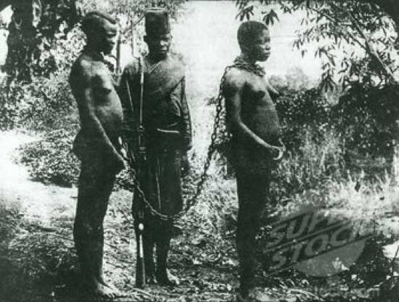**NUMBER 1 Congo Free State -** Genocide

Profiting from genocide and turning a blind eye to it is one thing, but only one organization has committed what can be called genocide for the sake of industry. Founded in 1885, by Leopold II, King of the Belgians, the Congo Free State garnered control over areas now known as the Congo, Rwanda and Burundi through a non-governmental organization, the Association Internationale Africaine. Leopold had acquired the Congo at the Berlin Conference of 1884, which was to regulate the European colonization of Africa.

While under the pretence of conducting humanitarian efforts, e.g. building churches and educating the people, it established an industry of collecting ivory, using huge amounts of slave labour. Surveyors hired by Leopold found that the greatest riches that the tribe’s people could access was ivory. Employing the Force Publique (a combination of a police force, tax collector and gang of enforcers, who had been drafted from able-bodied Congolese men to serve the State), the men would troop along rivers finding villages, separating the men, women and children (rape was exceedingly common) and telling the men that if they did not find a certain amount of ivory they would never see their families again, though a lot of the time the families had already died of disease. Collecting ivory became harder once the elephant population had been decimated, so the FP changed tactics to frightening the villagers away and taking any supplies left behind, then burning everything to the ground.

The other chief export was rubber, Leopold wanted the workers to be proficient and highly motivated so this meant that failing to meet rubber collection quotas was punishable by death. The officers in charge of a particular village would have to bring the hands of those who didn’t reach their quotas as proof that the officers hadn’t used the bullets to hunt for food. Some soldiers “cheated” by simply cutting of the hand, and leaving them to die, saving ammunition. This even caused small wars between villages; hands had become a valuable item to have, as they can be handed into the officer when they couldn’t fill their unrealistic quota.

The entire control of the nation was put under very few people and King Leopold was the definite ruler (he ditched the façade of the Association Internationale Africaine soon into his rule). He directly maintained the country more than just about all other dictators before, and since, and it was his policy that for each bullet fired, a hand must be represented as proof it was used to kill a Congolese worker. This was purely for the sake of cost-cutting. He was running the most cost-efficient company the world had seen.

The rubber and ivory industry was grinding to a halt due to the lack of motivation for slaves and the dwindling supply of ivory. Leopold was amassing severe debts, until the rubber boom of the 1890s, which was needed for telegraph wire and car tyres. Rubber overtook ivory as the country’s main export, and profits went through the roof.

Estimates of the number of deaths that King Leopold II and the Congo Free State caused range from 10 million to 22 million, both valid claims. It also should be noted that, at the time, Africa’s entire population was between 90 and 133 million people.

The Congo Free State ended in 1908, after whispers of the crimes happening in the Congo became shouts. The Congo Reform Movement, which included among its members Mark Twain, Joseph Conrad, Booker T. Washington and Bertrand Russell, led a vigorous international movement against the mistreatment of the Congolese population. The European nations had finally decided that Leopold was abusing the Berlin Treaty, and so it was annexed to Belgium, who retained it until 1960.

Leopold never intended to keep the nation for a long time, it was his twenty year get-rich-quick scheme, and it worked. Leopold died the wealthiest man in Europe after living the high-life, spending the massive profits on his favourite luxuries: expensive homes, yachts and teenage prostitutes.

Refer to the above article and answer the questions that follow:

1. Examine your personal outlook on life, do you believe “Moral absolutism or Moral relativism” would be a better reflection of you? Explain why. [5]
2. Highlight the major unethical issues raised in each ‘story’. [9]
3. Link each of the three companies to an ethical theory and then substantiate why you chose that particular theory. [12]
4. Identify at least two levels of ethics in each ‘story’. Name the level and substantiate why. [18]
5. Choose one of the above ‘stories’ and write a brief “Code of Ethics” for the particular perpetrating company/organisation. [6]

**Total: 50 marks**

**Business Studies**

Memo

**Worksheet: Business Ethic**

1. Examine your personal outlook on life, do you believe “Moral absolutism or Moral relativism” would be a better reflection of you? Explain why. [5]

Pupils to give their own answer – Pupils must substantiate

1. Highlight the major unethical issues raised in each ‘story’. [9]

**Matthias Rath -** Alternative treatments for HIV/AIDS

Letting people die for financial gain

Unethical advertising

Misrepresentation and false accusations

Fraud

False rumours

**Siemens - Aiding** the Final Solution

Unethical behaviour – exploitation

Discrimination against the Jews

Unacceptable working conditions

Violation of human rights

**Congo Free State –** Genocide

Slavery

Burning down of homes

Exploitation of workers

Environmental abuse

Murder

Rape/sexual harassment

1. Link each of the three companies to an ethical theory and then substantiate why you chose that particular theory. [12]

**Matthias Rath -** Alternative treatments for HIV/AIDS

**Consequence based theory –** He did possibly believe it would help, however, the outcome was not ethical.

**Virtue based theory –** His character might not have been bad because he wanted to cure cancer/HIV, however, his actions were terrible.

**Utilitarian theory –** The outcome if you look at the majority of the people – it was unethical

**Siemens - Aiding** the Final Solution

**Consequence based theory –** His actions might have been unethical, however, the outcome of the result for the business was positive

**Virtue based theory –** They made bad moral/judgement calls then, however, they have good character as these people and families are being compensated now.

**Principle based theory –** It is always wrong to kill, not matter what the circumstances are.

**Narrative based theory –** Always hearing of stories about Hitler days and how the Jews persecuted and how wrong it was.

**Congo Free State –** Genocide

**Utilitarian based theory –** For the greater number of people weren’t benefited – The minority in this case that benefitted.

**Principle based theory –** It is always wrong to kill, not matter what the circumstances are.

1. Identify at least two levels of ethics in each ‘story’. Name the level and substantiate why. [18]

**Matthias Rath -** Alternative treatments for HIV/AIDS

Professional level – He lied about vitamins and he is a professional (Dr)

Societal – impacted negatively because it was a social issue – injustice done to a whole society

International – business based in UK

Organisational – Expected employees to overlook wrong doings

Individual – He initially started the company so it was his lies

**Siemens - Aiding** the Final Solution

Societal – impacted negatively because it was murder of a society – injustice done to a whole society

International level – violating human rights because Siemens is an international company, slave trade.

Organisational – Siemens and staff were building gas stoves.

**Congo Free State –** Genocide

International - Business was identified as one of the most unethical business system/practice in the world. Plus other countries had to try intervene. Financially wealthy country tried to exploit a weaker country.

Organisational – Employees were asked to chop off workers hands – unethical

Individual – King Leopal was dictating all murders and punishments

Societal – Put society in danger by putting unethical rules into place.

1. Choose one of the above ‘stories’ and write a brief “Code of Ethics” for the particular perpetrating company/organisation. [6]

Eg: Congo – The business must do all its dealings in an honest, humane and ethical manner.

The business must not involve itself in any illegal and unprofessional activities

All staff to abide by the company vision and mission (Make sure the company’s vision and mission are aligned with this – Gov. Act)

**Total: 50 marks**